Standard Work Instruction
Wheelchair Accessible Vehicle
(Transporter)
載運輪椅使用者車輛
標準作業要領書

Wheelchair Accessible Vehicle Work Instructions載運輪椅車輛施工

Remove Operation- Car Seat and Car Seat Foot
(拆除作業-車內座椅及座椅腳座)
Steps  步驟 | Standard Operation Descriptions標準操作說明 |  | Instrument or Equipment  使用儀器  或設備 | Tools or Gauge  使用工具或治具
 | Photos圖 | Descriptions文
 | 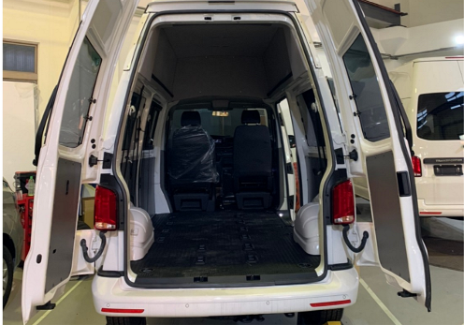 | Remove the single seat, double seat, and third seat in order.  依順序拆下單人座椅、雙人座椅、三人座椅。 |  | hand  手
 | 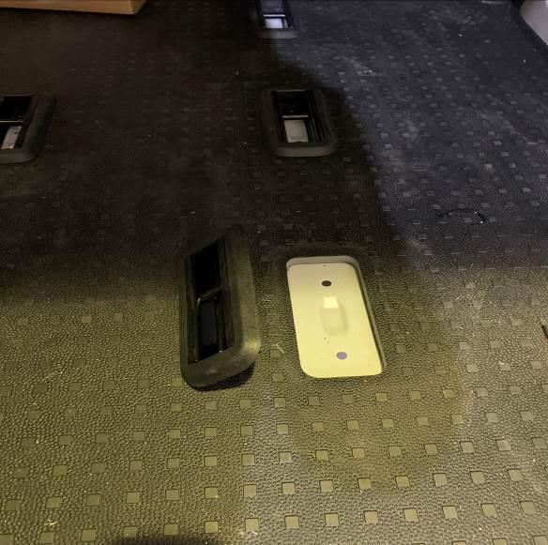 | Remove the fixing screws and the car seat feet.  拆下座椅腳座固定螺絲及腳座。 | air compressor  空壓機 | Socket set  套筒組
Visually inspect the interior of the vehicle and remove the appearance. It cannot be touched, scratched or damaged.
目視檢查車輛內裝拆除外觀不可碰、刮傷，不可毀損。
Visually check that the removed original screws and fixing buckles which are intact and undamaged.
目視檢查拆除後的原廠螺絲、固定扣外觀完整無損傷。
If NG occurs in any of the above steps, immediately re-adjust until the inspection is passed.
若上述任何步驟的發生NG,立即重新調適至檢驗通過為止。

Installation of regulatory accessories - warning light, buzzer installation and cable pulling
(法規配件安裝作業-警示燈、蜂鳴器安裝及拉線)
Steps  步驟 | Standard Operation Descriptions  標準操作說明 |  |  | Instrument or Equipment  使用儀器  或設備 | Tools or Gauge  使用工具或治具
 | Photos圖 |  | Descriptions文
 | 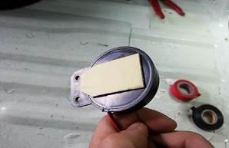 |  | Paste heat-resistant double-sided tape on the back of the buzzer body.  蜂鳴器本體背面黏上耐熱雙面膠。 |  | Hand  手
 | 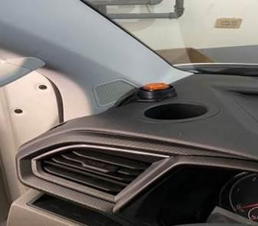 |  | Paste it next to the cup holder on the left side of the driver's seat.  黏貼於駕駛座左邊置杯架旁。 |  | Hand  手
 | 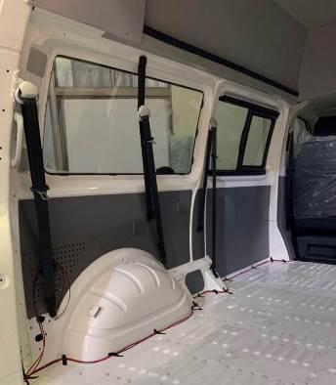 |  | The line runs along the A-pillar to the floor to the tailgate.  線路沿著A柱往地板延伸至尾門。 |  | Hand  手
 | 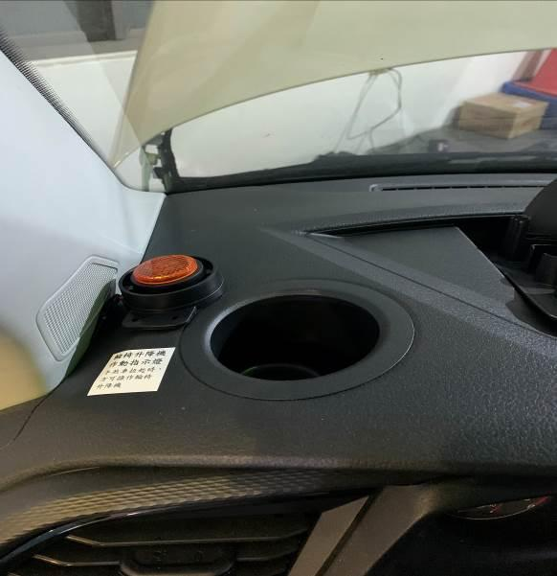 |  | Paste instruction stickers.  黏貼說明貼紙。 |  | Hand  手
 |  |  | Paste heat-resistant double-sided tape on the back of the warning light body.  警示燈本體背後黏上耐熱雙面膠。 |  | Hand  手
 |  | 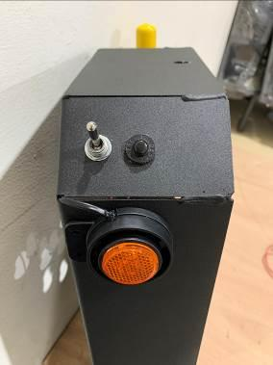 | Paste on the electric control box of the lift.  黏貼於升降機電控箱上。 |  | Hand  手
Visually check that the position of the warning light is located at the designated position of the driver's seat and lift control box.
目視檢查警示燈位置位於駕駛座及升降機控制箱指定位置。
 |  | The buzzer and warning lights need to be activated when the lift is started.  操作辨音檢查蜂鳴器及警示燈於升降機啟動時需動作。 |  |  | Hand  手
If NG occurs in any of the above steps, immediately re-adjust until the inspection is passed.
若上述任何步驟的發生NG,立即重新調適至檢驗通過為止。

Installation of regulatory accessories - handbrake switch installation and cable pulling
(法規配件安裝作業-手煞車開關安裝及拉線)
Steps  步驟 |  | Standard Operation Descriptions  標準操作說明 |  | Instrument or Equipment  使用儀器  或設備 | Tools or Gauge  使用工具或治具
 |  | Photos圖 | Descriptions文
 |  | 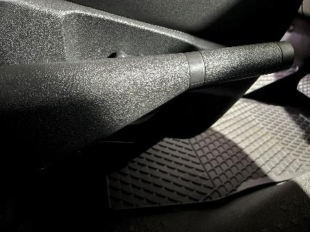 | Unlock the buckle at the bottom, and remove the upper cover of the front handbrake.  解開下方卡扣，拆下前端手煞車上護蓋。 |  | hand  手
 |  | 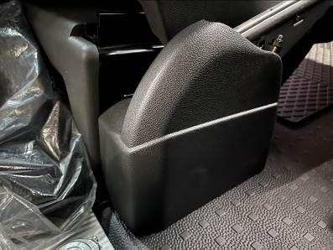 | Apply upward force to remove the lower cover of the handbrake.  向上施力將手剎車底下護蓋拆下。 |  | hand  手
 |  | 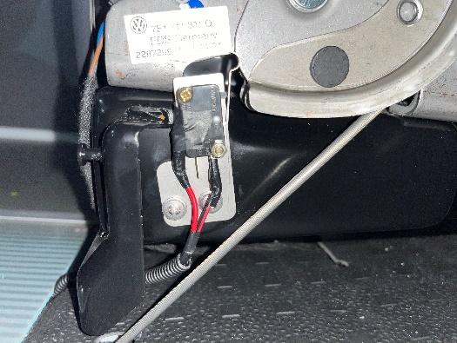 | The two poles of the micro switch are connected to the signal line, leaving an appropriate length and pulled out from the bottom cover of the handbrake.  微動開關兩極接上訊號線，留適當長度由手剎車底部飾蓋拉出。 |  | Fitter group  鉗工組
 |  | 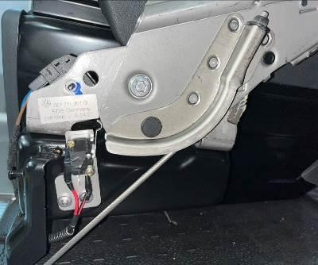 | Adjust until the micro switch is touched when the handbrake is put down, and leave the micro switch when pulled up.  調整至放下手剎車即觸動微動開關，拉起時離開微動開關。 |  | hand  手
 |  | 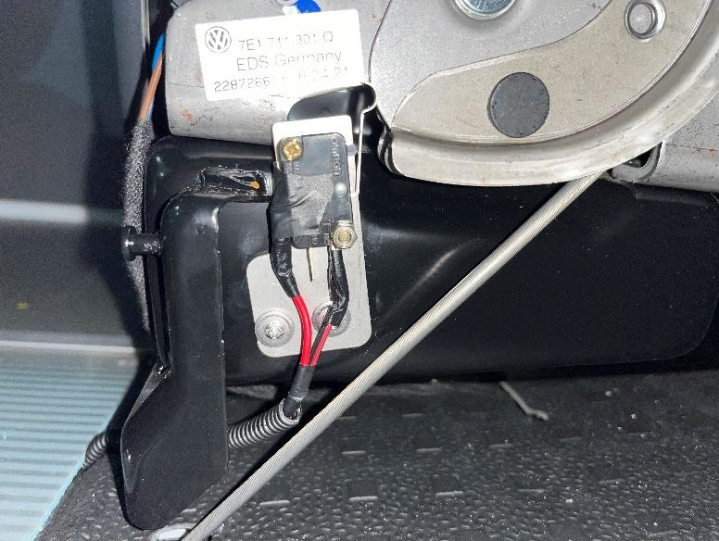 | The parking brake switch is positioned with the handbrake mechanism, and locked with two 4/8" self-drilling screws, and it is firm.  手煞車開關與手煞車機構定位，用2顆4分自攻螺絲鎖上，並且穩固。 |  | Electric impact driver  電動衝擊起子機
Visually check whether the terminals of the micro switch of handbrake are completely covered and there are no exposed wires.
目視檢查手煞車微動開關端子是否包覆完整電線無裸露。
 |  | 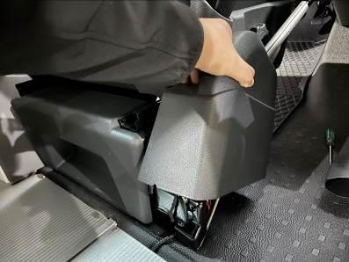 | Close the driver's seat trim cover and press down along the buckle to replace the handbrake lower cover.  靠緊駕駛座飾蓋沿卡扣下押裝回手煞車下護蓋。 |  | hand  手
 |  | 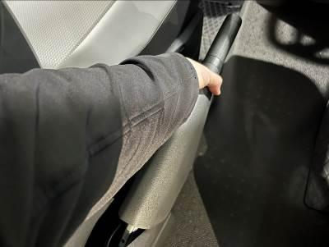 | Install the original handbrake upper cover along the handbrake handle.  順著手剎車手柄裝回原廠手煞車上護蓋。 |  | hand  手
Manual operation check that the lift cannot start when the handbrake is put down.
手動操作檢查手煞車放下時升降機無法啟動。
Manual operation Check that the lift can start when the handbrake is pulled up.
手動操作檢查手煞車拉起時升降機能夠啟動。
If NG occurs in any of the above steps, immediately re-adjust until the inspection is passed.
若上述任何步驟的發生NG,立即重新調適至檢驗通過為止。

Installation of regulatory accessories - installation of handle for wheelchair users in the vehicle
(法規配件安裝作業-車內輪椅使用者扶手安裝)
Steps  步驟 |  | Standard Operation Descriptions  標準操作說明 |  | Instrument or Equipment  使用儀器  或設備 | Tools or Gauge  使用工具或治具
 |  | Photos圖 | Descriptions文
 |  | 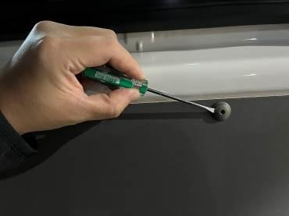 | Remove all the original plastic buckles of the right door and right side trim, and remove the right door trim.  拆下右側門及右側飾板全部原廠塑膠扣，拆下右側門飾板。 |  | Screwdriver set  螺絲起子組
 |  | 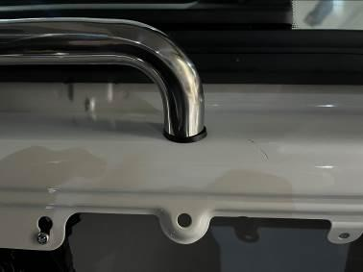 | Use the stainless-steel handle to make marks on the sheet metal under the edge of the door and the glass window on the right side of the compartment, and drill a Φ8 through hole.  利用不鏽鋼扶手於車門及車廂右側玻璃窗戶緣下板金做記號，鑽Φ8通孔。 | Tape measure  捲尺 | Vibrating electric drill  震動電鑽
 |  | 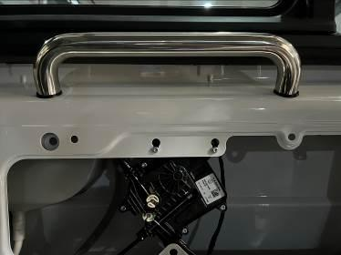 | The handle is aligned with the holes, and the screws are locked with the handle from the inside of the sheet metal.  扶手對齊孔位，螺絲由板金內與扶手對鎖鎖緊。 |  | Wrench tool set  扳手工具組
Manually confirm the tightening force of the handle lock in the car, and do not shake when applying force by hand.
手動確認車內扶手鎖緊固力，用手施力時不晃動。
 |  | 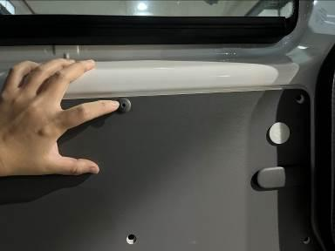 | Put the original factory trim on.  將原廠飾板放上。 |  | hand  手
 |  | 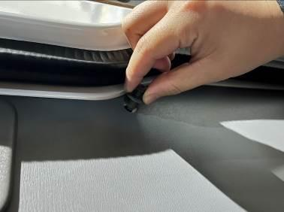 | All original plastic buckles are snapped back.  原廠塑膠扣全部扣回。 |  | hand  手
If NG occurs in any of the above steps, immediately re-adjust until the inspection is passed.
上述任何步驟的發生NG,立即重新調適至檢驗通過為止。

Installation of regulatory accessories – tailgate handle installation
(法規配件安裝作業-尾門把手安裝)
Steps  步驟 |  | Standard Operation Descriptions  標準操作說明 |  | Instrument or Equipment  使用儀器  或設備 | Tools or Gauge  使用工具或治具
 |  | Photos圖 | Descriptions文
 |  | 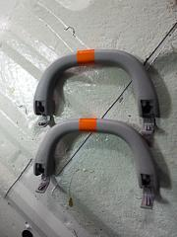 | Put reflective stickers on the handle.  將把手貼上反光貼紙。
 |  | 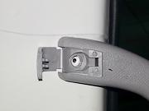 | Fix to the marked line position.  固定至標線位置。
 |  | 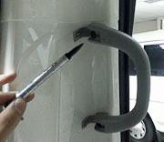 | Mark the mark.  標示記號。
 |  | 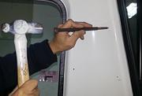 | Use center punch marks.  使用中心衝標記。
 |  | 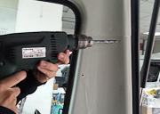 | Drill the hole Φ10.  鑽孔Φ10。 |  | Vibrating electric drill  震動電鑽
 |  | 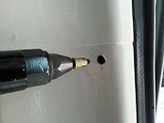 | Put the cap gun in.  拉帽槍放入。 | air compressor  空壓機 | Pneumatic cap puller  氣動拉帽機
 |  | 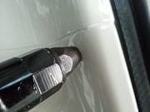 | Use pull cap to make tooth extraction.  使用拉帽造牙。 | air compressor  空壓機 | Pneumatic cap puller  氣動拉帽機
 |  | 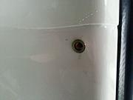 | Finished fixed teeth.  完成固定牙製作。 | air compressor  空壓機 | Pneumatic cap puller  氣動拉帽機
 |  | 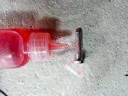 | Apply fixative for screws. (Screw glue)  螺絲塗抹固定劑(螺絲膠)。
 |  | 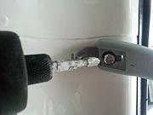 | Use blunt cross electric to lock.  使用鈍十字電動鎖緊。 |  | Electric impact driver  電動衝擊起子機
 |  | 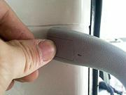 | Cover the handle screw cover  蓋上扶手螺絲蓋。 |  | Hand  手
 |  | 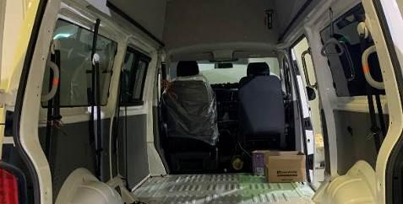 | Apply reflective stickers on the rear-door handle.  尾門扶手貼上反光貼紙。
Manually confirm the fastening force of the tailgate handle, and do not shake when applying force by hand.
手動確認尾門扶手緊固力，用手施力時不晃動。
Visually check that the reflective identification sticker on the tailgate handle is smooth and not loose
目視檢查尾門扶手反光識別貼紙平整無鬆脫。
If NG occurs in any of the above steps, immediately re-adjust until the inspection is passed.
若上述任何步驟的發生NG,立即重新調適至檢驗通過為止。

Positive wire installation and pulling
(正電線安裝及拉線)
Steps  步驟 | Standard Operation Descriptions  標準操作說明 |  | Instrument or Equipment  使用儀器  或設備 | Tools or Gauge  使用工具或治具
 | Photos圖 | Descriptions文
 | 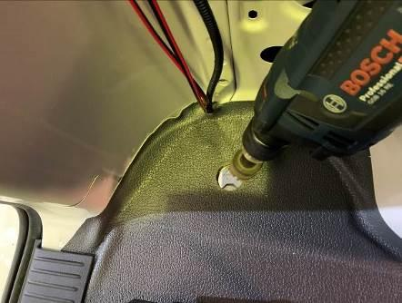 | Use hole drill Φ30mm. And put in the insulating protective cover.  使用穴鑽Φ30mm。並放入絕緣保護套。 |  | Vibrating electric drill  震動電鑽
 | 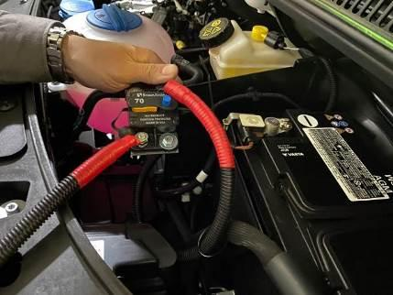 | Put in a short positive wire to connect the battery to the power supply terminal of the external circuit breaker.  放入短正電線將電瓶與外接斷路器進電端連接。
 | 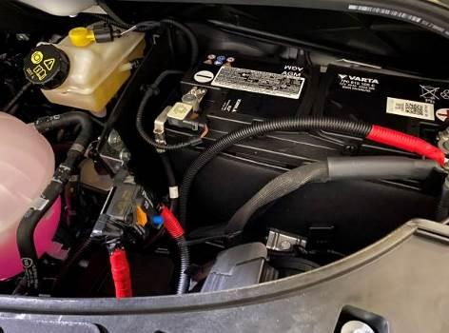 | Fix the circuit breaker on the insulating plate on the left side of the battery, and make sure that no other conductors are overlapped.  將斷路器固定於電瓶左側隔絕板上，並確保無搭接其他導體。 |  | Wrench tool set  扳手工具組  Electric impact driver  電動衝擊起子機  Insulated terminal crimping pliers  絕緣端子壓線鉗
- 4 | Put the positive wire on the car coil and route it to the bottom of the car, and pull it out along the refrigerant pipe, the edge guard of the fuel tank, and through the rear beam.  將正電線套上蛇管往車底走線，沿冷媒管、油箱邊緣護板、穿過後橫樑拉出。  Warning: At this step, attention should be paid to avoid high temperature, transmission shaft, linkage parts and areas prone to wear when fixing the positive wire.  ※此步驟應注意正電線固定時須避開高溫、傳動軸、連動件及易磨損之區域！
 | 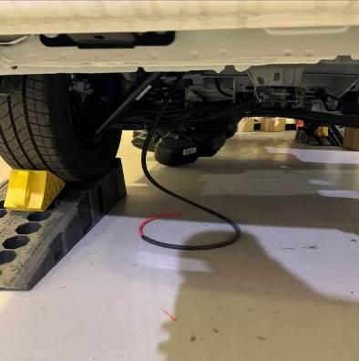 | Pull the positive wire from the bottom of the car through the Φ30mm hole drilled before and keep it in the car.  將正電線由車底穿過剛才鑽的Φ30mm孔牽至車內保留。
- 5 | 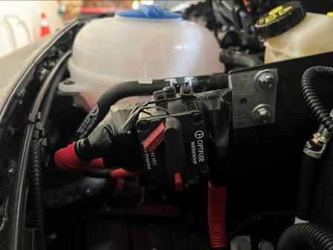 | The lap joint of the circuit breaker is covered with insulating tape, and the positive wire is covered with the car coil to avoid short circuit caused by wear and tear.  斷路器搭接處用絕緣膠帶包覆，正電線包覆蛇管避免磨損造成短路。
Visually inspect the positive wire route to avoid high temperature, transmission shaft, linkage parts and rub area.
目視檢查正電線走線時避開高溫、傳動軸、連動件及易磨損之區域。
Visually inspect the appearance of the lap joint of the circuit breaker and wrap it with insulating tape, and wrap the positive wire with the car coil.
目視檢查斷路器搭接處外觀用絕緣膠帶包覆，正電線包覆蛇管。
Manually check that the lift circuit breaker is installed and locked without shaking
手動檢查升降機斷路器安裝鎖固不晃動。
Visually check whether the lap joints of the circuit breaker terminals are covered with electric fire cloth and cannot be exposed.
目視檢查斷路器端子搭接處是否用電火布包覆不可外露。
Visually inspect the appearance of the positive wire and wrap it with a car coil.
目視檢查正電線外觀用蛇管纏繞包覆。
If NG occurs in any of the above steps, immediately re-adjust until the inspection is passed.
若上述任何步驟的發生NG,立即重新調適至檢驗通過為止。

Ground construction work in the vehicle - laying the floor (aluminum-plastic plate)
(車內地面施工作業-鋪設地板(鋁塑板))
Steps  步驟 |  | Standard Operation Descriptions  標準操作說明 |  | Instrument or Equipment  使用儀器  或設備 | Tools or Gauge  使用工具或治具
 |  | Photos圖 | Descriptions文
 |  | 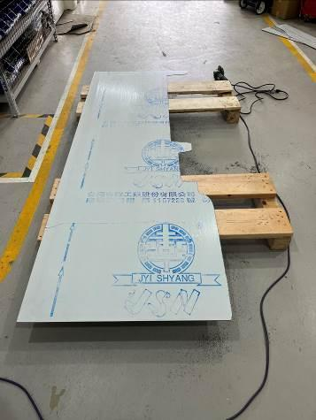 | Cut the aluminum-plastic plate into a suitable shape according to the dimension diagram of the interior space of the car.  將鋁板依車內空間尺寸圖切割出合適形狀。 |  | Circular saw  圓鋸機  Wire saw machine  線鋸機
 |  | 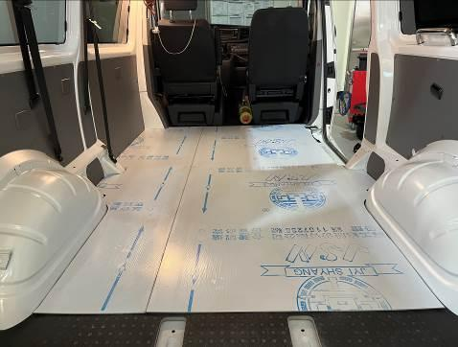 | Lay the aluminum-plastic plates in order, and align the edges of the pressure plates of the left and right sliding doors.  依序將鋁塑板鋪上，對齊左右拉門壓板邊緣。
 |  | 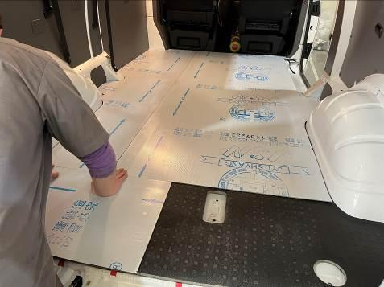 | Lay the aluminum-plastic plates on the tailgate in sequence.  依序將尾門部分鋁塑板鋪上。
 |  | 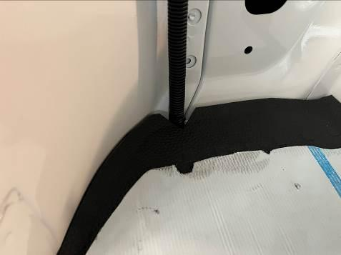 | Cable holes are reserved.  走線孔預留。
 |  | 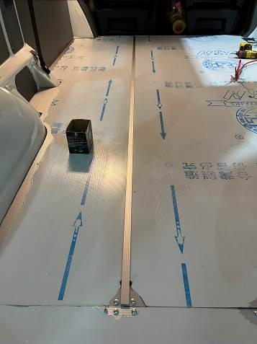 | Attach aluminum layering tile trim.  上鋁壓條。
 |  | 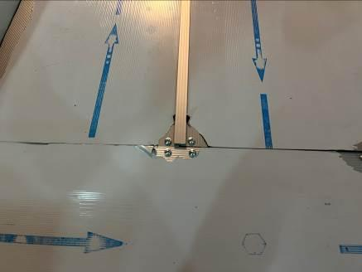 | Position and fix the aluminum-plastic panel with self-tapping screws.  用自攻螺絲定位並固定鋁塑板。 |  | Electric impact driver  電動衝擊起子機
 |  | 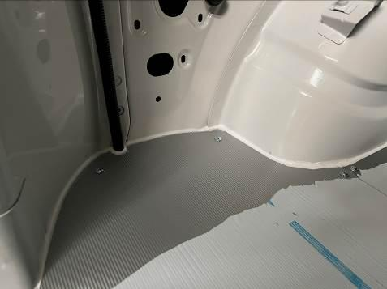 | Fill the seams with silicone.  打矽利康把邊縫補齊。
Visually check that the appearance of the aluminum floor cannot be touched, scratched or damaged.
目視檢查鋁地板外觀不可碰、刮傷，不可毀損。
 |  | Use a tape measure to check that the gap between the joints of the aluminum floor is less than 5mm.  捲尺檢查鋁地板拼接處間隙小於5mm。 |  | Tape measure  捲尺 | Socket set  套筒組
Carry out the sound identification inspection to check the flatness of the aluminum floor laying, and there should be no abnormal sound when stepping on it.
辨音檢查鋁地板鋪設平整度踩踏時不可有異音。
Visually check that the pipelines and wires at the connection between the aluminum floor and the decorative panel are not exposed.
目視檢查鋁地板與飾板連接處管線及電線不可裸露。
If NG occurs in any of the above steps, immediately re-adjust until the inspection is passed.
若上述任何步驟的發生NG,立即重新調適至檢驗通過為止。

Installation of interior accessories - wheelchair restraint installation
(車內配件安裝作業-輪椅束縛器安裝)
Steps  步驟 |  | Standard Operation Descriptions  標準操作說明 |  | Instrument or Equipment  使用儀器  或設備 | Tools or Gauge  使用工具或治具
 |  | Photos圖 | Descriptions文
 |  | 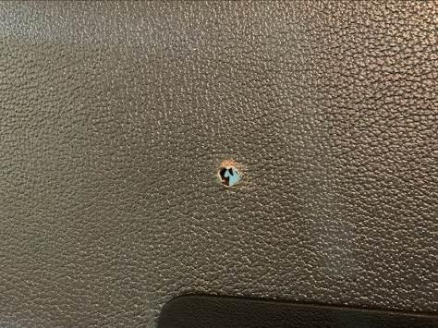 | Use the drill tail to drill the Φ12 keyhole at the specified position.  使用鑽尾將指定位置鑽Φ12鎖孔。 |  | Vibrating electric drill  震動電鑽
 |  | 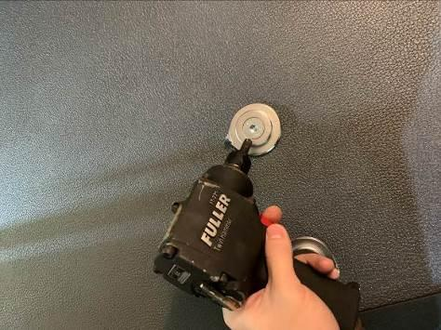 | Put in the fixing plate and screws.  放入固定盤及螺絲。 | Air compressor  空壓機 | Pneumatic ratchet wrench  氣動棘輪板手
 |  | 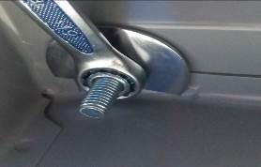 | Lock the fixed plate with the washer.  將固定盤與墊片對鎖。 |  | Wrench tool set  扳手工具組
 |  | 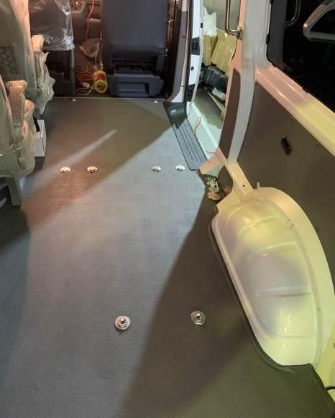 | Complete implementation.  完成圖。 | Air compressor  空壓機 | Electric impact driver  電動衝擊起子機Wrench tool set  扳手工具組Socket set  套筒組  Pneumatic ratchet wrench  氣動棘輪板手
 |  | Use a wrench to check that the fixing seat is locked and cannot be shaken.  扳手檢查固定座鎖固不可晃動。 |  | Air compressor  空壓機 | Wrench tool set  扳手工具組
 |  | Use a torque wrench to check the screw torque of the fixing seat 38±3Nm.  扭力扳手檢查固定座螺絲扭力38±3N‧m。 |  | Torque wrench  扭力板手 | Socket set  套筒組
 |  | Use a tape measure to check the size and direction of the fixing seat and lock it according to the configuration diagram.  捲尺檢查固定座尺寸及方向依配置圖鎖附。 |  | Tape measure  捲尺
If NG occurs in any of the above steps, immediately re-adjust until the inspection is passed.
若上述任何步驟的發生NG,立即重新調適至檢驗通過為止。

Lift installation work - drilling and installation of lift base holes
(升降機安裝作業-升降機底座孔位鑽孔及安裝)
Steps  步驟 |  | Standard Operation Descriptions  標準操作說明 |  | Instrument or Equipment  使用儀器  或設備 | Tools or Gauge  使用工具或治具
 |  | Photos圖 | Descriptions文
 |  | 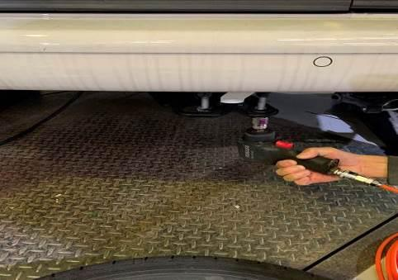 | Use a No. 19 socket to loosen the spare wheel screw.  使用19號套筒鬆開備胎螺絲。 | Air compressor  空壓機 | Pneumatic Impact Wrench  氣動衝擊扳手  Socket set  套筒組
 |  | 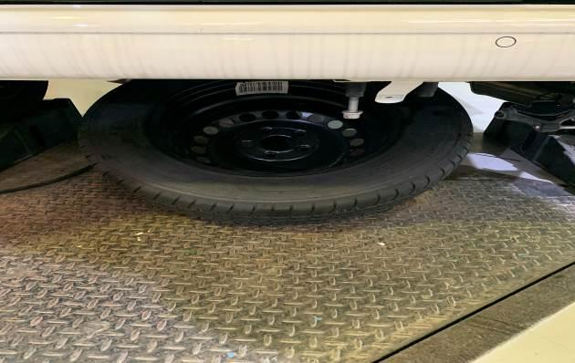 | Remove the spare wheel.  卸下備胎。 |  | Pneumatic ratchet wrench  氣動棘輪板手  Socket set  套筒組
 |  | 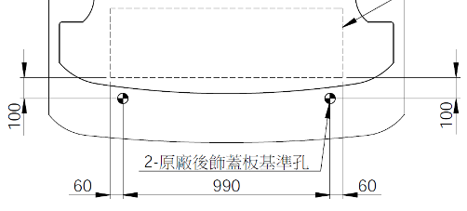  附圖單位：mm | Place the lift as shown in the figure and move it to a place 100mm from the edge of the base to the locking point of the original tailgate trim.  依圖示放上升降機移至底座邊緣距離原廠尾門飾蓋鎖點100mm處。 |  | Lift drilling gauge  升降機鑽孔治具
 |  | 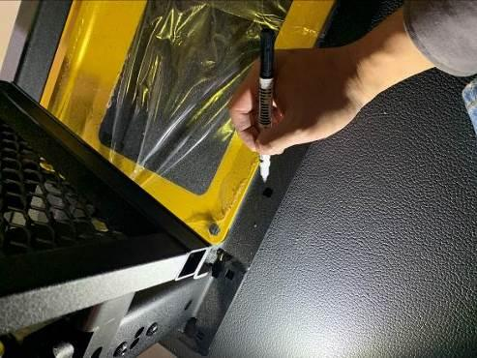 | Mark the position of the lift fixing keyhole.  標記升降機固定鎖孔位置。 |  | Fitter group  鉗工組
 |  | 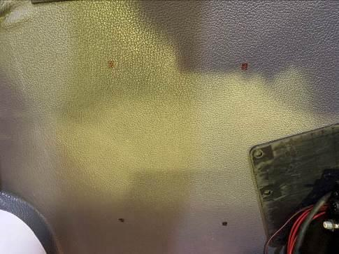 | Use an electric drill to drill a Φ6.5 through hole at the mark.  使用電鑽在標記處鑽Φ6.5通孔。 |  | Vibrating electric drill  震動電鑽
 |  | 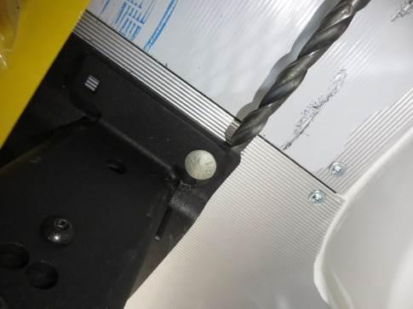 | se an electric drill based on the Φ6.5 through hole, and use a Φ26 hole drill to remove the remaining material on sheet metal part under the car.  使用電鑽以Φ6.5通孔為依據，用Φ26穴鑽將車底板金以上的餘料移除。 |  | Vibrating electric drill  震動電鑽
 |  |  | Use an electric drill to expand the Φ6.5 through hole of the sheet metal part under the car to Φ12.  用電鑽把車底板金的Φ6.5通孔擴孔至Φ12。 |  | Vibrating electric drill  震動電鑽
 |  | 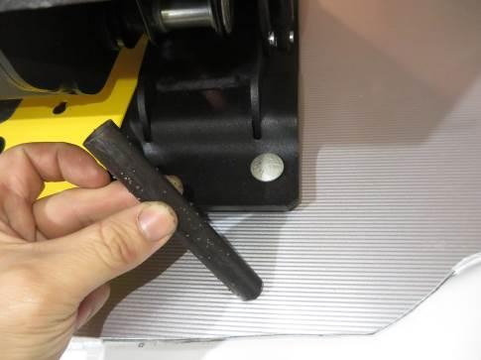 | Put in the support cylinder.  放入支撐圓柱。
 |  | 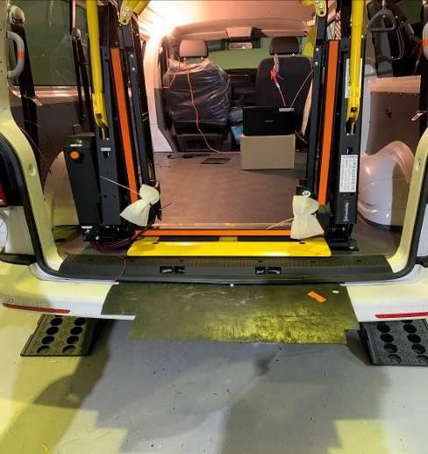 | Place protective pads.  放置防護墊及防護墊板。
 |  | 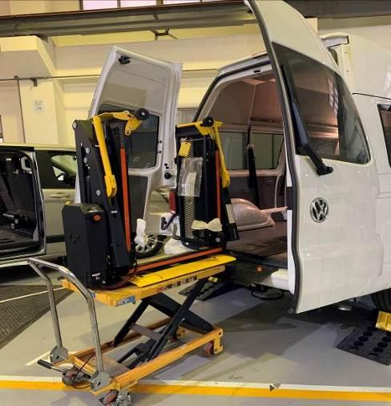 | Push the lift into the fixed position in the car.  將升降機推入車內固定位置。 |  | Hydraulic lifting platform  油壓升降平台
 |  | 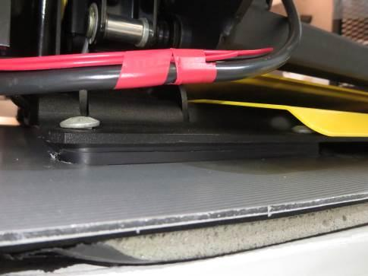 | As shown in the picture, place a 12mm backing plate under the lift base.如圖，打圈處升降機底座下方放置12mm墊板。
 |  | 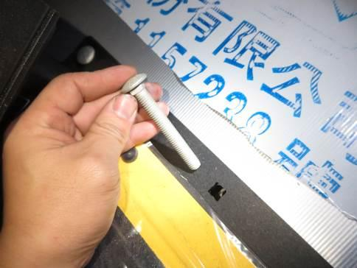 | Thread the screw holes into the carriage screws and adjust until the square neck of the screw sinks into the lift base.  螺絲孔穿入馬車螺絲並調整至螺絲方頸部分沉入升降機底座。
 |  | 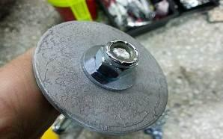 | Install gaskets and nuts to lock the elevator to the car body.  安裝墊片與螺帽將升降機與車體對鎖。 |  | Pneumatic ratchet wrench  氣動棘輪板手  Socket set  套筒組  Wrench tool set  扳手工具組Pneumatic ratchet wrench  氣動棘輪板手
 |  | 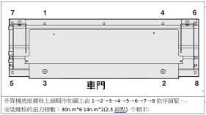 | lock in order.  依照順序鎖緊。 |  | Wrench tool set  扳手工具組Socket set  套筒組  Pneumatic ratchet wrench  氣動棘輪板手
 |  | 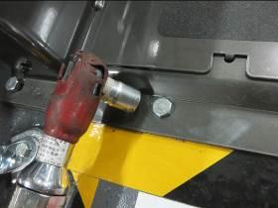 | Use pneumatic wrench or ratchet wrench to fix and lock.  使用氣動扳手或棘輪扳手固定鎖緊。 |  | Pneumatic ratchet wrench  氣動棘輪板手  Socket set  套筒組
 |  | 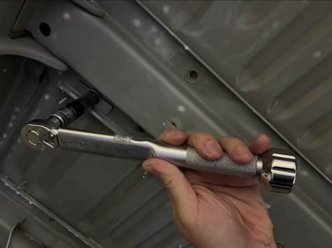 | Lock with a torque wrench (just hear two beeps).  用扭力板手鎖緊(聽到兩聲即可)。 | Torque wrench  扭力板手  40N.m*6  14N.m*2 | Socket set  套筒組
 |  | Check the tightening torque of the nut with a torque wrench to 40±3Nm.  扭力板手檢查螺帽鎖緊扭力40±3N‧m。 |  | Torque wrench  扭力板手 | Socket set  套筒組
 |  |  | Put the spare tire back on.  將備胎裝回。 |  | Pneumatic ratchet wrench  氣動棘輪板手  Socket set  套筒組
Manually and visually check that the fixed part of the spare wheel is shaken and there is no contact with the lift screw.
手動目視檢查備胎安裝穩固部晃動且無碰觸升降機螺絲。
If NG occurs in any of the above steps, immediately re-adjust until the inspection is passed.
若上述任何步驟的發生NG,立即重新調適至檢驗通過為止。

Lift installation work - external circuit
(升降機安裝作業-外接電路)
Steps  步驟 |  | Standard Operation Descriptions  標準操作說明 |  | Instrument or Equipment  使用儀器  或設備 | Tools or Gauge  使用工具或治具
 |  | Photos圖 | Descriptions文
 |  | 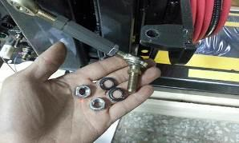 | Install the screw at the end of the lift rod and confirm that it is locked.  安裝升降機杆端螺絲，並且確認鎖緊。 |  | Wrench tool set  扳手工具組  Socket set  套筒組
 |  | 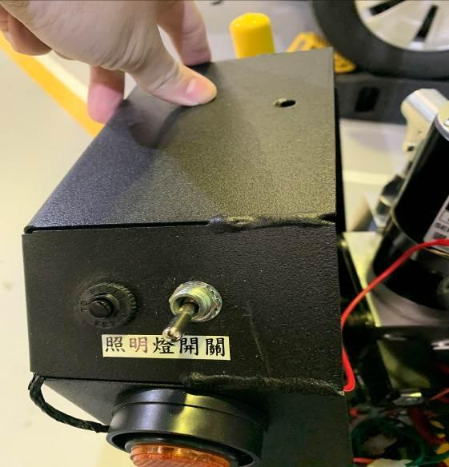 | Open the case and find the lighting circuit.  開啟機箱找到照明燈線路。
 |  | 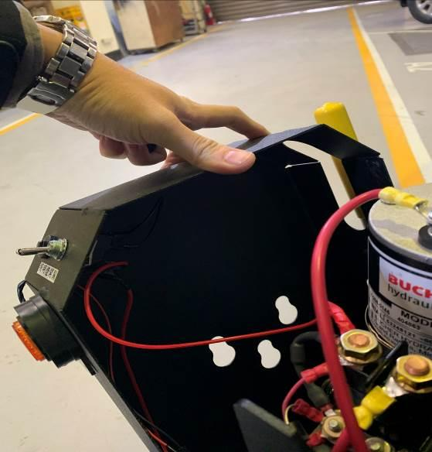 | The lighting circuit is externally connected to a positive electricity.  照明燈線路外接一條正電。 |  | Fitter group  鉗工組
 |  | 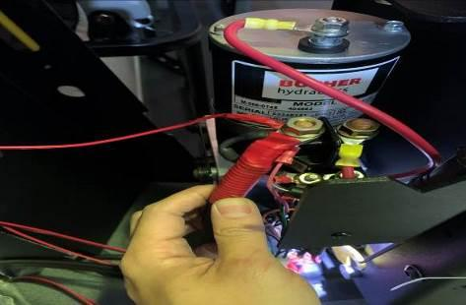 | Install positive wire and handbrake control wire and put on the red insulating sleeve.  安裝正電線與手煞車控制線。 |  | Wrench tool set  扳手工具組
 |  | 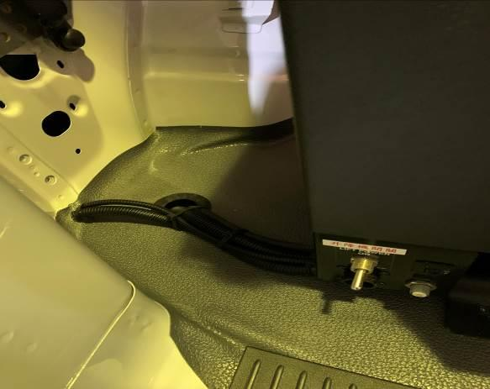 | The positive electricity of the lift is installed firmly.  升降機正電安裝牢固套上紅色絕緣套。
 |  | 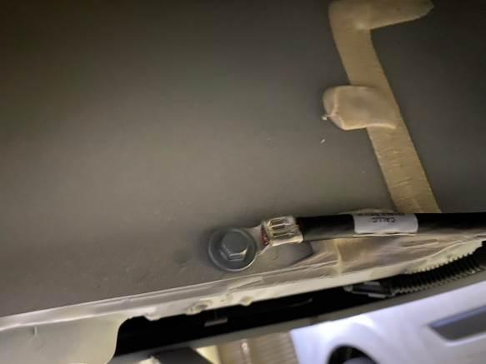 | Connect the lift negative electricity to the car body.  升降機負電連接車體。 |  | Wrench tool set  扳手工具組
Keep excess wires neatly organized and secured with tie wraps.
將過長的電線整齊放好並使用束帶固定。
 |  | 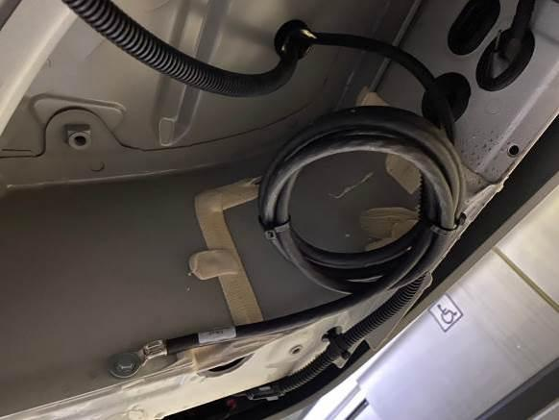 | Visually check the negative wire binding ring of the lift is tight and does not interfere with the shock absorber.  目視檢查升降機負電線捆圈束緊不干涉避震器。
If NG occurs in any of the above steps, immediately re-adjust until the inspection is passed.
若上述任何步驟的發生NG,立即重新調適至檢驗通過為止。

Finishing cleaning of the vehicle interior - pasting stickers for the wheelchair area
(車輛內裝收尾清潔作業-黏貼輪椅區貼紙)
Steps  步驟 |  | Standard Operation Descriptions  標準操作說明 |  | Instrument or Equipment  使用儀器  或設備 | Tools or Gauge  使用工具或治具
 |  | Photos圖 | Descriptions文
 |  | 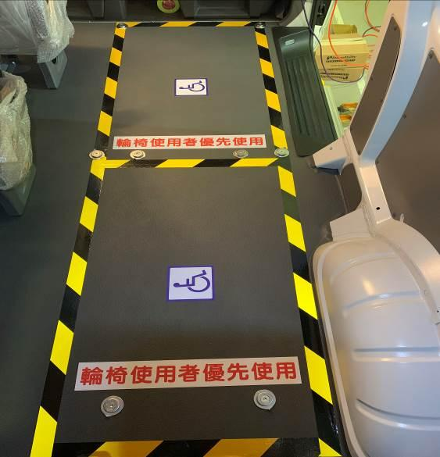 | Paste the wheelchair area stickers according to the work order.  依工單黏貼輪椅區貼紙。 | Tape measure  捲尺
 |  | 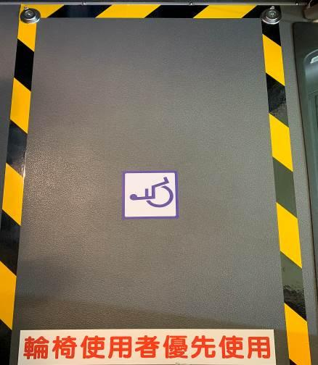 | Apply wheelchair person stickers.  黏貼輪椅人貼紙。
 |  | 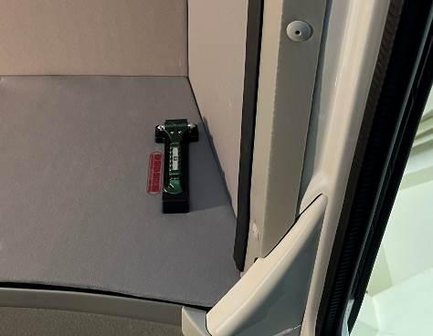 | Visually check whether the window breakers and stickers are installed.  目視檢查車窗擊破器及貼紙是否有安裝。
 |  | 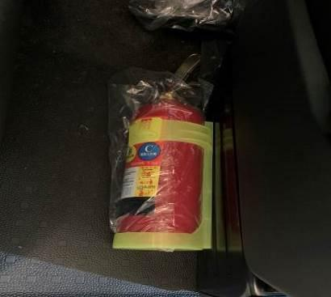 | Visually check that the fire extinguisher is placed next to the passenger seat.  目視檢查滅火器是否放置副駕駛座位旁。
 |  | 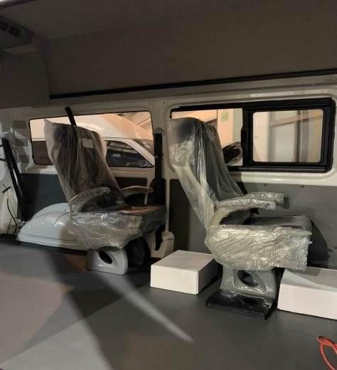  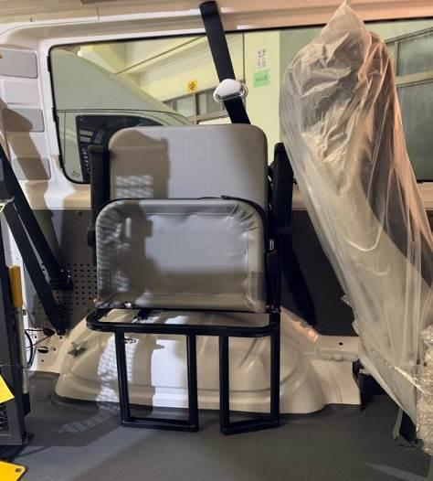 | Install two single-person forward chairs and single-person folding chairs.  安裝兩張單人正向椅、單人摺疊椅。
Manually check that the side seats are locked and ready for riding, and the seating position does not shake.
手動檢查側椅鎖緊可供乘坐，乘坐部位不晃動。
Visually check that the seat belts are fully stowed and the screws are locked.
目視檢查座椅安全帶收納完整，螺絲鎖緊。
Visually inspect the side seats for no trauma and keep it clean.
目視檢查側椅無外傷，保持清潔。
If NG occurs in any of the above steps, immediately re-adjust until the inspection is passed.
若上述任何步驟的發生NG,立即重新調適至檢驗通過為止。

Construction work of two single seat and folding seat
(正向椅及折疊椅施工作業)
Steps  步驟 | Standard Operation Descriptions  標準操作說明 |  | Instrument or Equipment  使用儀器  或設備 | Tools or Gauge  使用工具或治具
 | Photos圖 | Descriptions文
 | 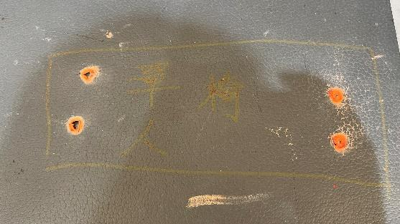 | Mark hole location.  標記孔位
 | 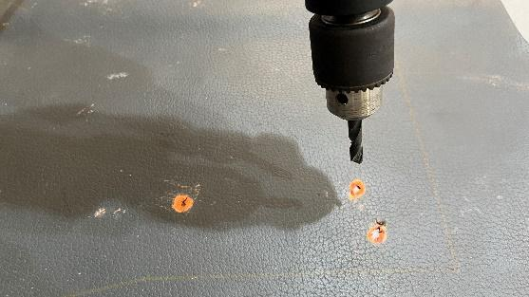 | Drill holes and remove burrs.  鑽孔並去除毛邊
 | 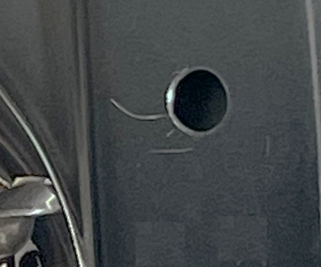 | Drill holes and remove burrs.  鑽孔並去除毛邊
 | 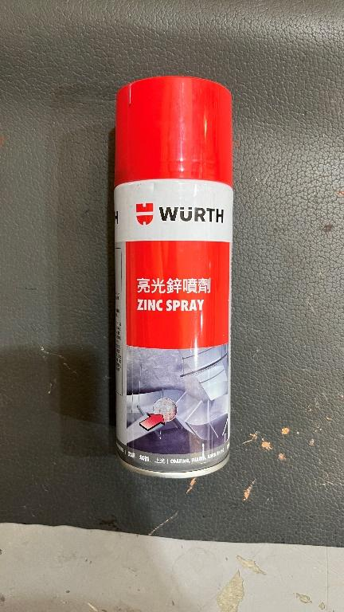 | Do anti-rust treatment.  防鏽處理
 | 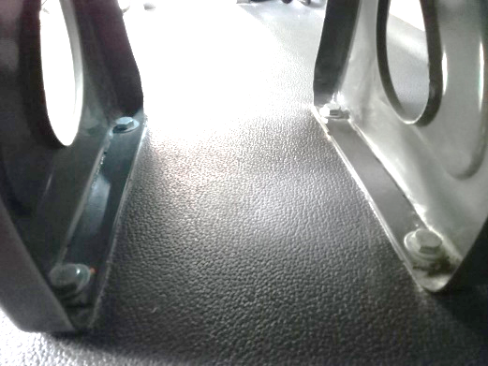 | Pleace seat and screw on the right position.  座椅及螺絲放置
 | 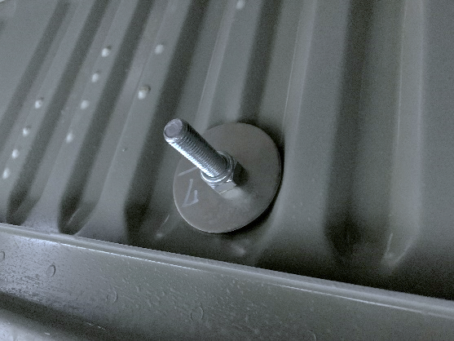 | Lock mounting gasket nut(locking torque  40±3N.m).  墊片螺帽鎖附安裝，鎖附扭力  40±3N．m
 | 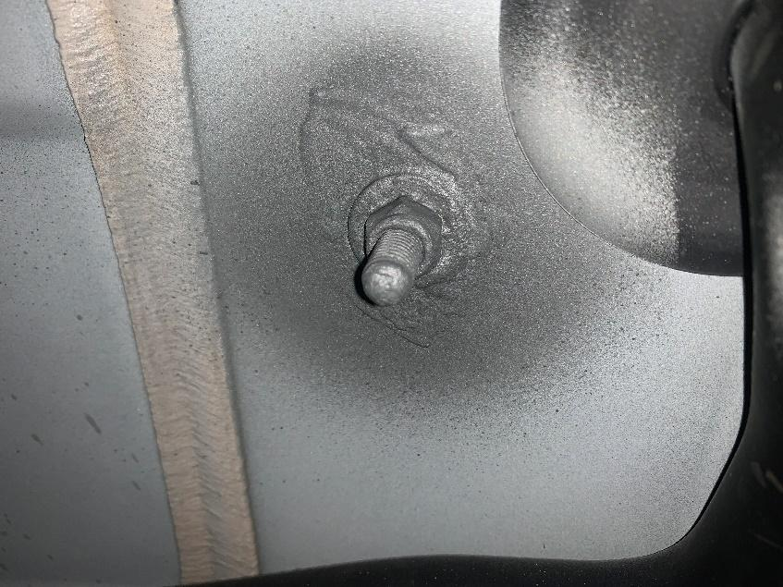 | Do anti-rust treatment.  防鏽處理
 | 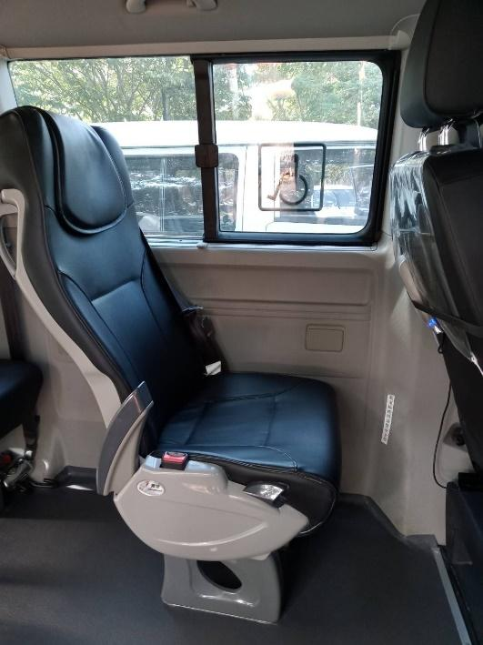 | Operation check to ensure that the seat is locked firmly and does not shake.  操作檢查座椅鎖附穩固不晃動
 | 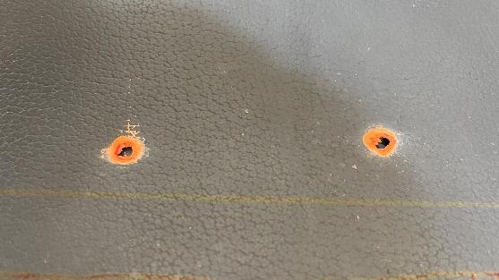 | Mark hole location.  標記孔位
 | 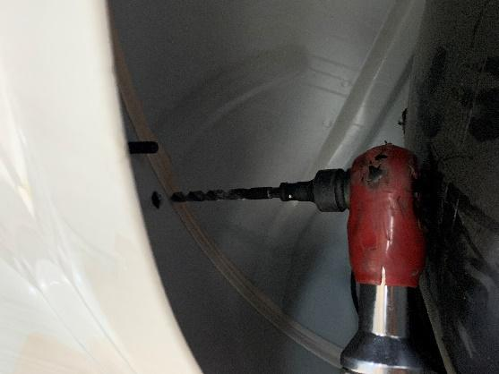 | Drill holes and remove burrs.  鑽孔並去除毛邊
 | 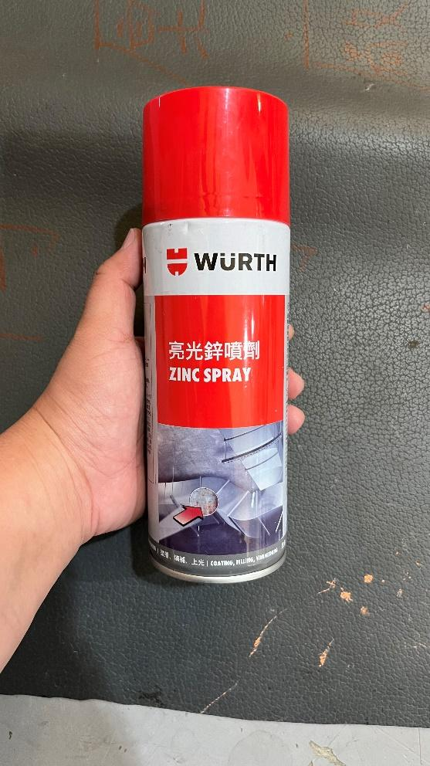 | Do anti-rust treatment.  防鏽處理
 | 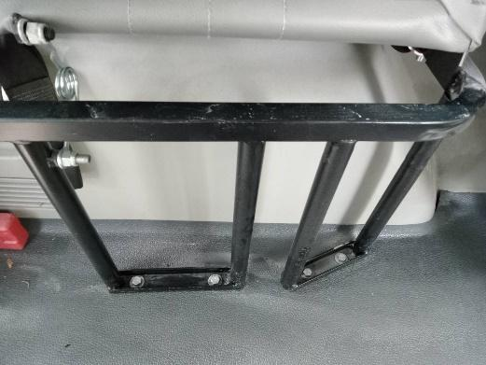 | Place Seat and screw on the right position for folding seat.  座椅及螺絲放置
 | 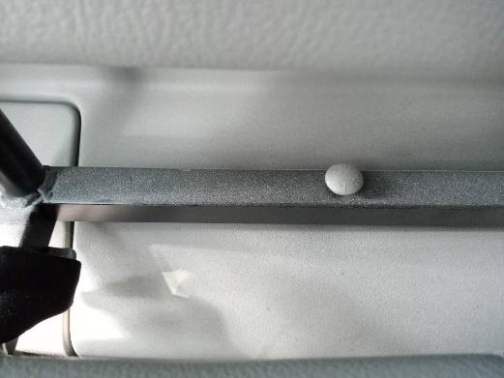 | Place Seat and screw on the right position for folding seat.  座椅及螺絲放置
 | 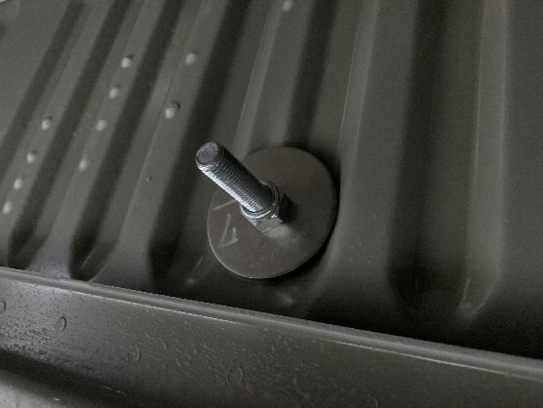 | Lock mounting gasket nut(locking torque  40±3N.m).  墊片螺帽鎖附安裝，鎖附扭力  40±3N．m
 | 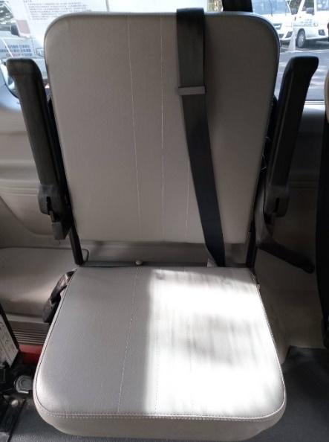 | Operation check to ensure that the seat is locked firmly and does not shake.  操作檢查座椅鎖附穩固不晃動
 | 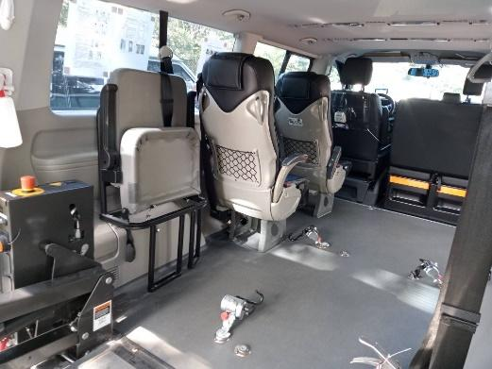 | Installation photos  安裝照片
 | 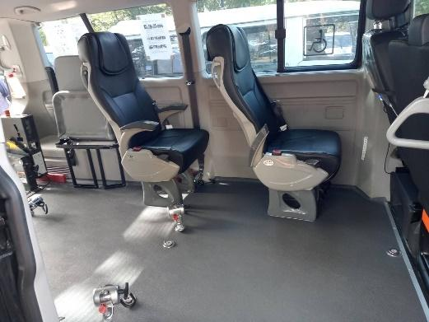 | Installation photos  安裝照片

